SE310 Computer Project II

Kevin Mai

The design constraints are shown below.

1. Crank of the four-bar mechanism should make a complete rotation. Crank is connected to the output shaft of the motor, so it has to make a complete rotation.
2. Four-bar mechanism and the wings should fit within a 200mm x 200mm footprint throughout its range of motion. The figure output of the Matlab program has its axis going from -100 to 100. Four-bar and wings should fit completely within this figure window.
3. Maximum wingspan (e) of the robot can be up to 100 mm.
4. The length of the crank O1A must be more than 10 mm.
5. Motor is assumed to have a constant angular velocity of 900 rpm. This value is taken as the angular velocity of the crank.
6. Wings should rotate more than 45deg and not more than 60deg about its pivot, O2.
7. Wing tip velocity at the mid-span of its traced path should be at least 6000 mm/second.

**Design I**

After an initial guess and check approach to finding a working first design, the following link lengths satisfies the above criteria.

a = 23mm (The crank)

b = 60mm (The coupler)

c = 50mm (The rocker)

d = 65mm (The fixed link)

e = 100m (The tip)

We can see the maximum wing span is less than or equal to 100mm and the length of the crank is more than 10mm, therefore satisfying the link constraints.

The following shows the maximum wing tip velocity and range of the wing’s rotation around its pivot, O2.

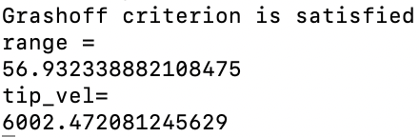

We can see that the Grashoff criterion is satisfied, the range is larger than 45deg and less than 60deg, and tip velocity is above 6000mm/sec, therefore satisfying all the criteria.

The following is the animation of the design.

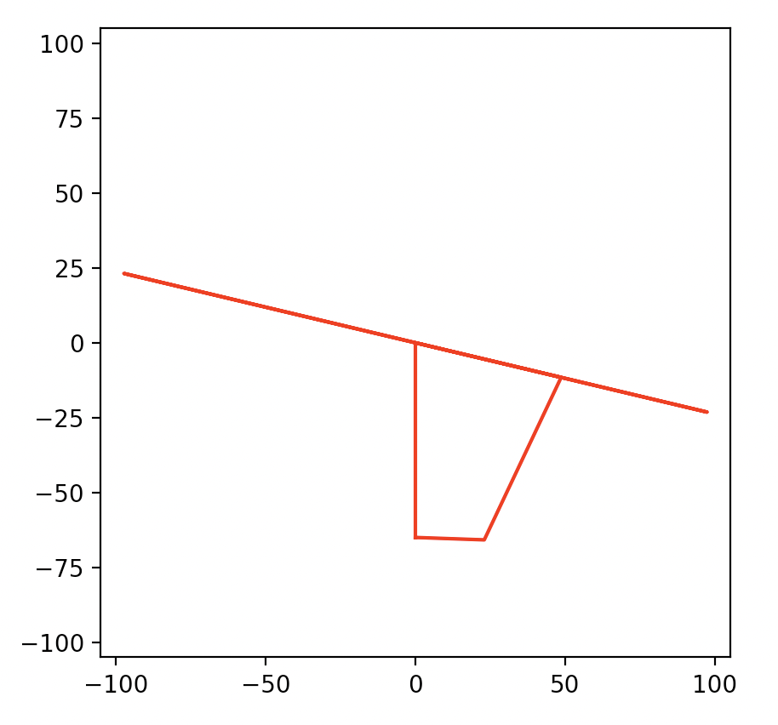

**Design II**

While tinkering with the link lengths, I noticed a few patterns.

1. The larger the tip length, the larger the tip velocity with no change in range. With this in mind, I decided to leave the tip length at its maximum value of 100mm.
2. Increasing the length of the crank/coupler increases tip velocity, but also pushes the range closer to the upper limit of 60deg.
3. Decreasing the length of the fixed link/rocker increases the tip velocity, but also pushes the range closer to the upper limit of 60deg.
4. The Grashoff criteria is not satisfied if a + 2max(link_length) > b + c + d

With all these in mind and the desire to increase tip velocity, I designed the following.

a = 20mm (The crank)

b = 60mm (The coupler)

c = 50mm (The rocker)

d = 50mm (The fixed link)

e = 100mm (The wing)

We can see the maximum wing span is less than or equal to 100mm and the length of the crank is more than 10mm, therefore satisfying the link constraints.

The following shows the maximum wing tip velocity and range of the wing’s rotation around its pivot, O2.

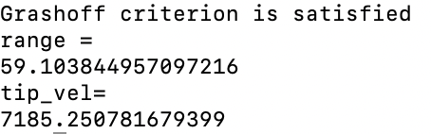

We can see that the Grashoff criterion is satisfied, the range is larger than 45deg and less than 60deg, and tip velocity is above 6000mm/sec and increased by 19.7% from the previous design, therefore satisfying all the criteria.

The following is the animation of the design.

